Diagrams created by Ismael Abou Coulibaly

GitHub repo link : <https://github.com/kamsi09/SW1_PW_Manager>

**Sequence Diagrams**

1 – Add entry

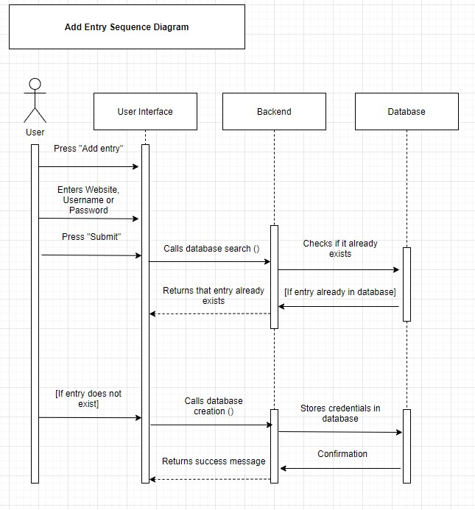

2 – Remove Entry

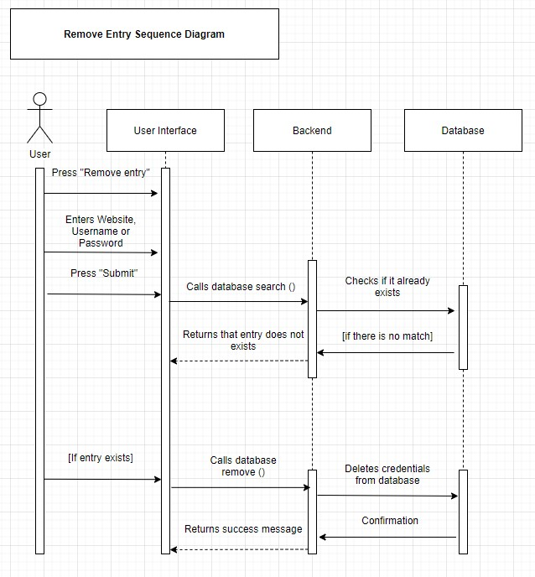

3 – Modify Entry

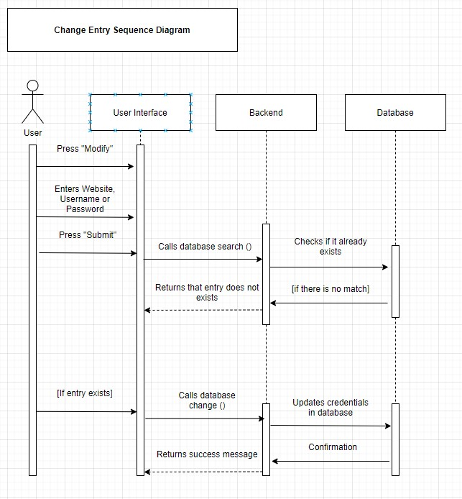

4 – Search entry

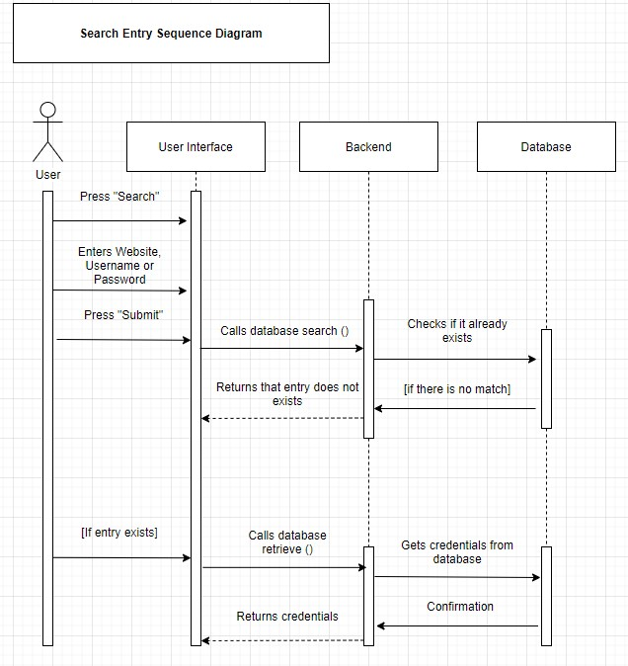

5 – View All

